LESSONS LEARNED
This project was a reasonable introduction to structuring java programs into separate classes that do 1 individual object and it’s required methods. It allowed me to practice logical separation of what objects do what tasks, and the relationships and dependencies that then build up between different classes. Some specific items that the project reinforced were:
Always validate user input.
Always consider edge cases, such as what to do if no players are listed (to prevent division by 0 for average age), and how to handle multiple players that match the same average height.
Handle integer math using divide and modulo.

DESIGN
UML
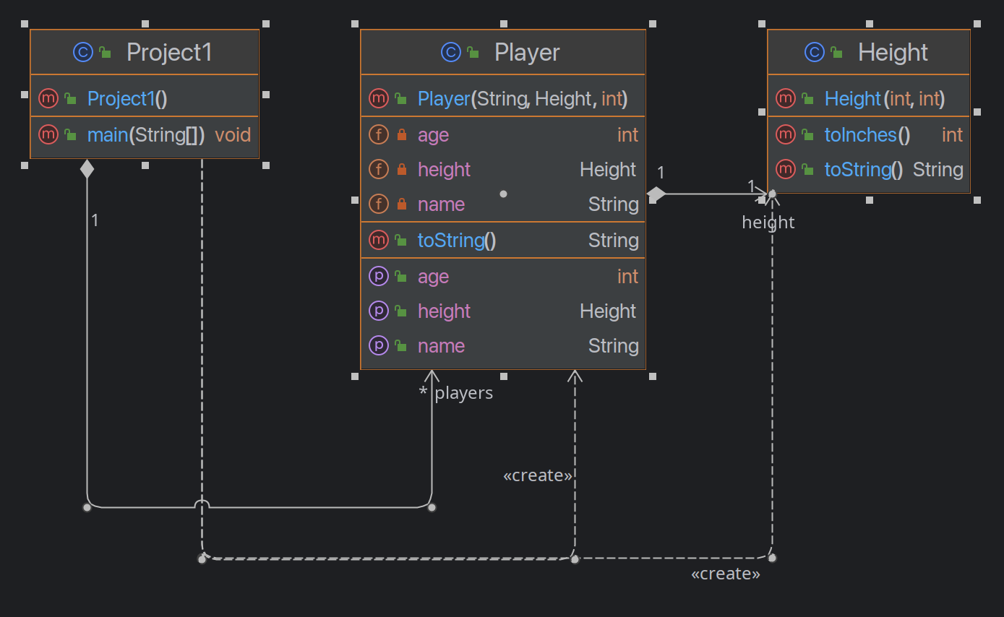

TEST PLAN
Test # | Input | Expected Output
1 | Validate that program will not error out if no players are listed:  Input: done | Output:  “No players to calculate average age.”
2 | Validate that calculations are correct if a player is 0” tall, and is aged 0 years.  Input:  Player1:  name: Aa Bb  Height: 5’ 11”  age: 16  Player2:  name: Cc Dd  Height: 0’ 0”  age: 0 | Output:  “Average age: 8  Tallest player: Aa Bb with a height of 71 inches (5' 11")”
3 | Validate that calculations are correct if a player is 0” tall, and is aged -10 years.  Input:  Player1:  name: Aa Bb  Height: 5’ 11”  age: 16  Player2:  name: Cc Dd  Height: 0’ 0”  age: -10 | Output:  “Average age: 3  Tallest player: Aa Bb with a height of 71 inches (5' 11")”
4 | Validate results if only 1 player is entered.  Player1:  name: Aa Bb  Height: 5’ 11”  age: 16 | Output:  “Average age: 16  Tallest player: Aa Bb with a height of 71 inches (5' 11")”
5 | Verify that entry is not accepted if height is given only in feet (that is, without inches).  Player1:  name: Aa Bb  Height: 5’  age: 16 | Please enter the players' information in response to the prompt.  Enter the player's name (or 'done' if you have entered all players): Aa Bb  Enter the player's height in feet and inches (e.g., 5 10): 5  Please enter the height in feet and inches.  Enter the player's name (or 'done' if you have entered all players):
6 | Validate results if a full roster of players is given. One player should have a height of some feet and 18 inches.  Player1:  name: Aa Bb  Height: 5’ 11”  age: 16  Player2:  name: Cc Dd  Height: 6’ 0”  age: 22  Player3:  name: Ee Ff  Height: 6’ 8”  age: 14  Player4:  name: Gg Hh  Height: 5’ 18”  age: 33  Player5:  name: Ii Jj  Height: 5’ 13”  age: 24 | Output:  “Average age: 21  Tallest player: Gg Hh with a height of 78 inches (6' 6")”

SCREEN SHOTS
1
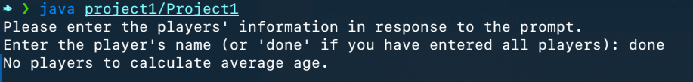
2
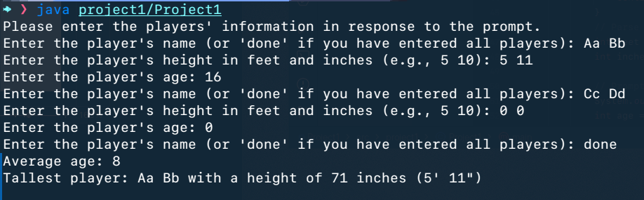
3
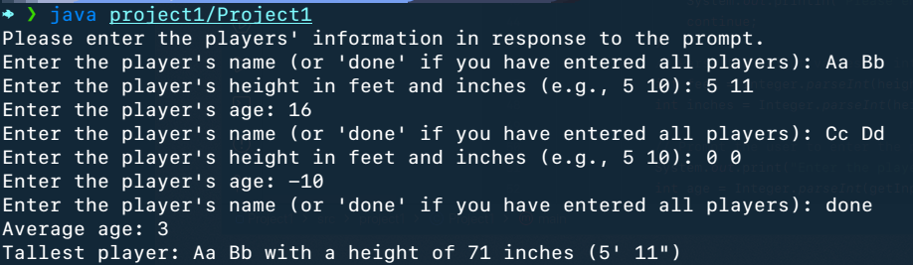
4
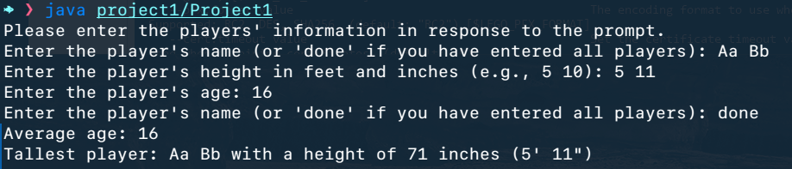
5
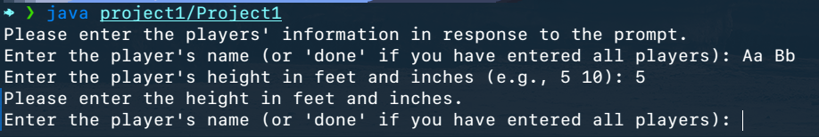
6
